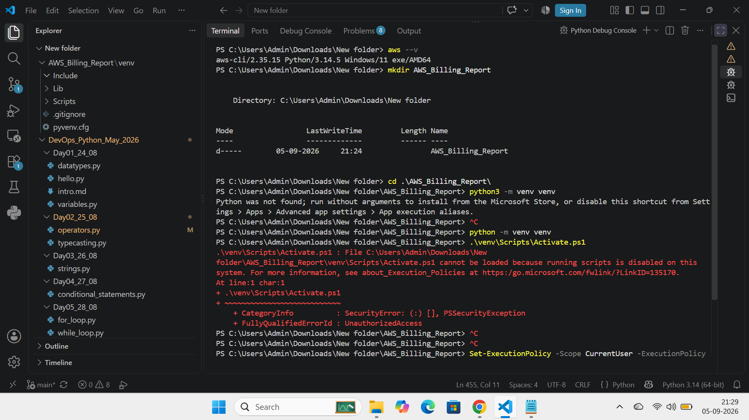
Step 1: Create directory and virtual environment and Activate the venv:
mkdir AWS_Billing_Report
cd AWS_Billing_Report
python -m venv venv

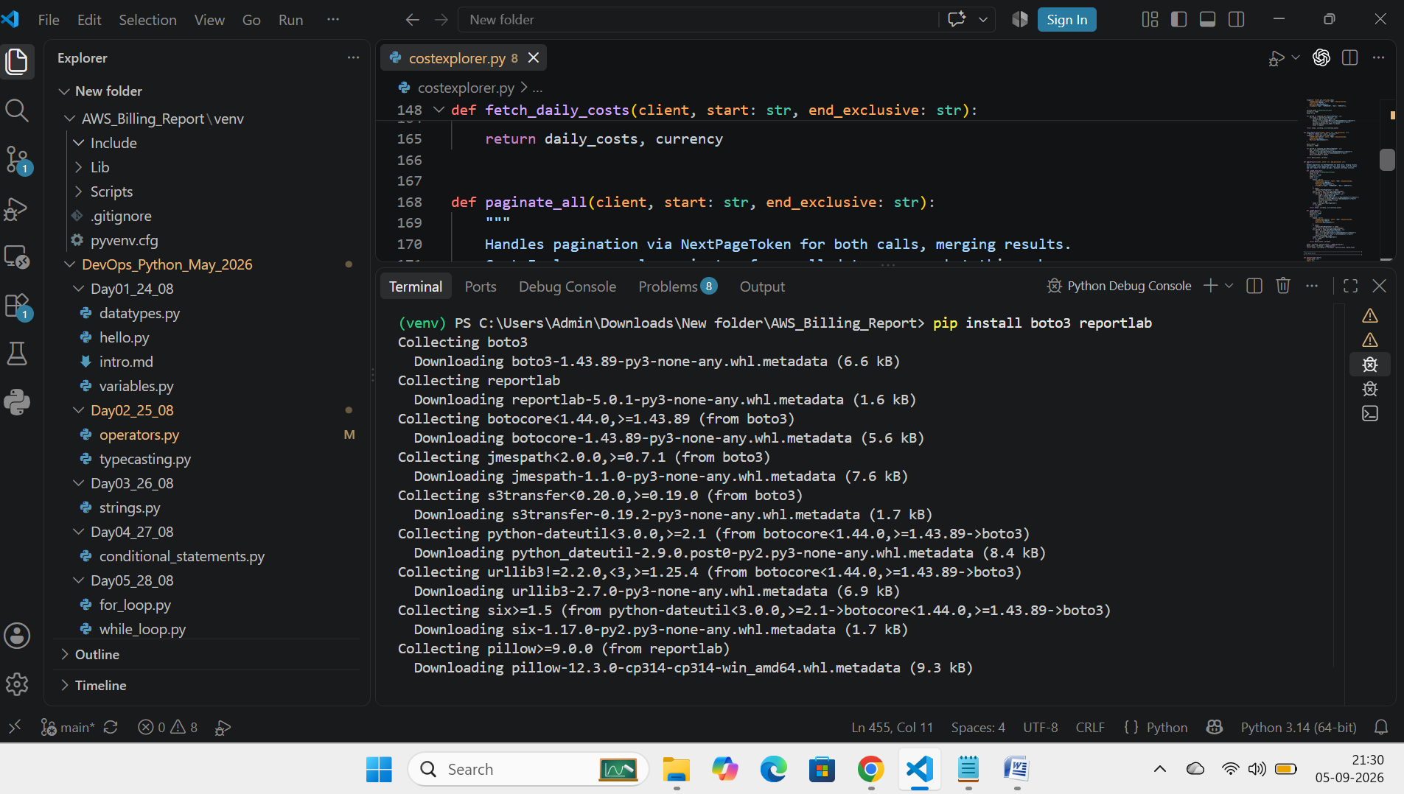
Step 2: Install Boto3 and ReportLab
pip install boto3 reportlab
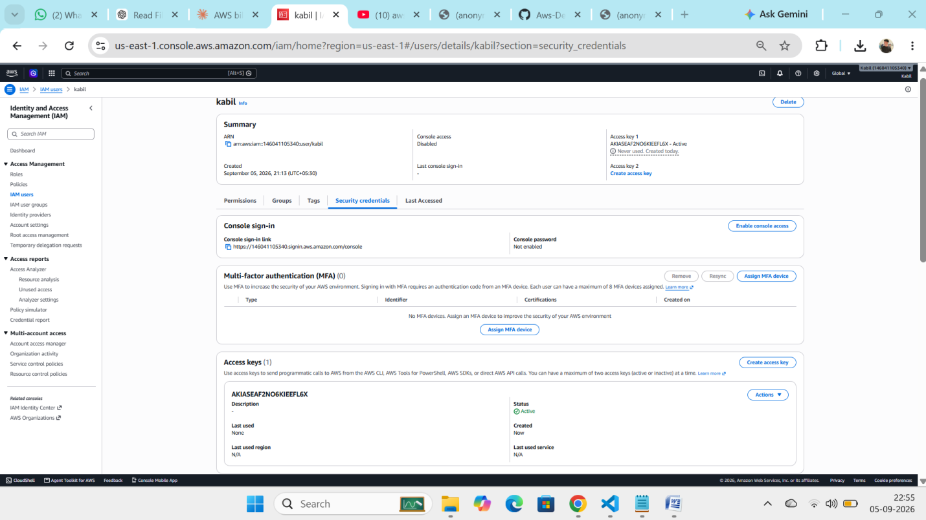
Step 3 : Create an IAM and create an Access key and secrete key
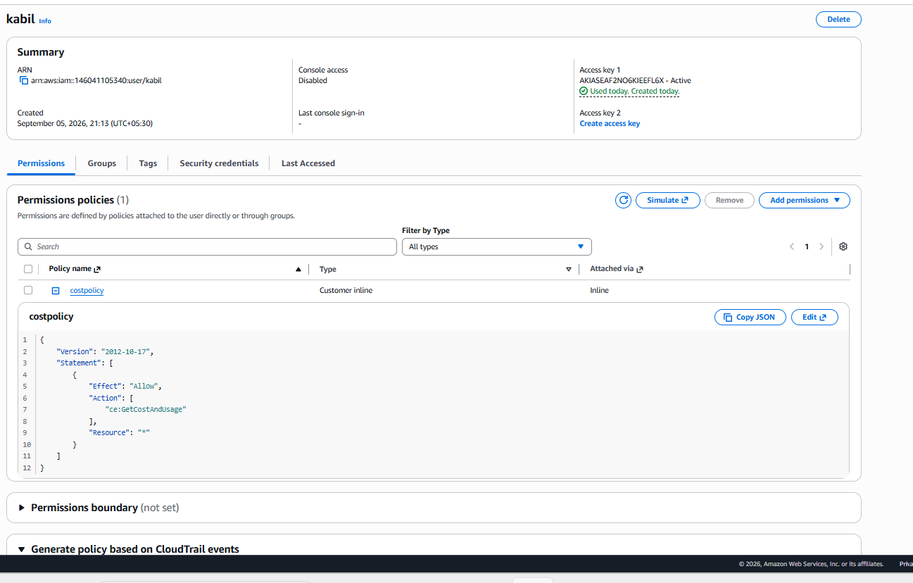
Step 3 : Assiging persmission to the IAM user (CE:GetcostAndUsage)

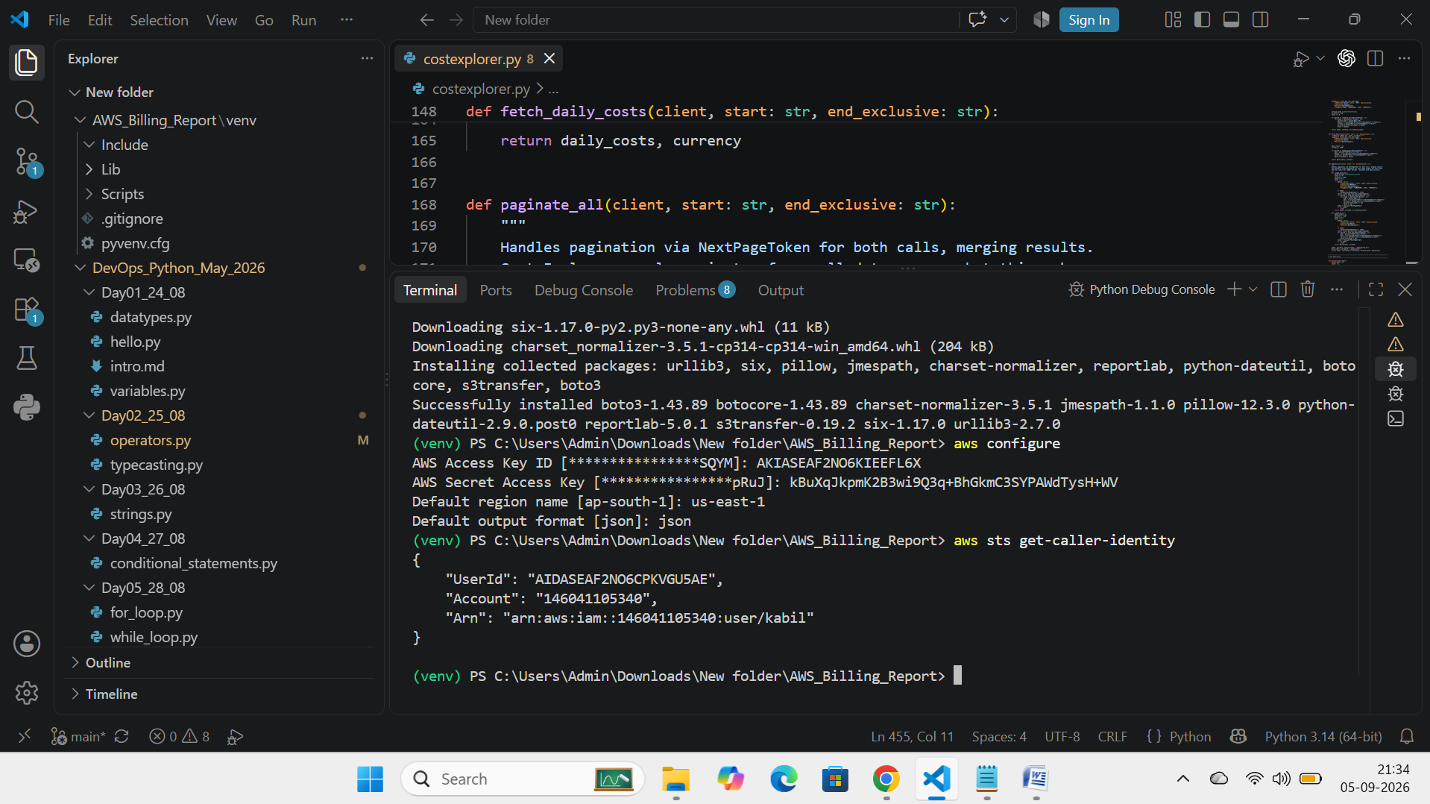

Step 5: Configure AWS credentials in Local machine
aws configure : and give the access an secret key credentials
aws sts get-caller-identity : Test the credential
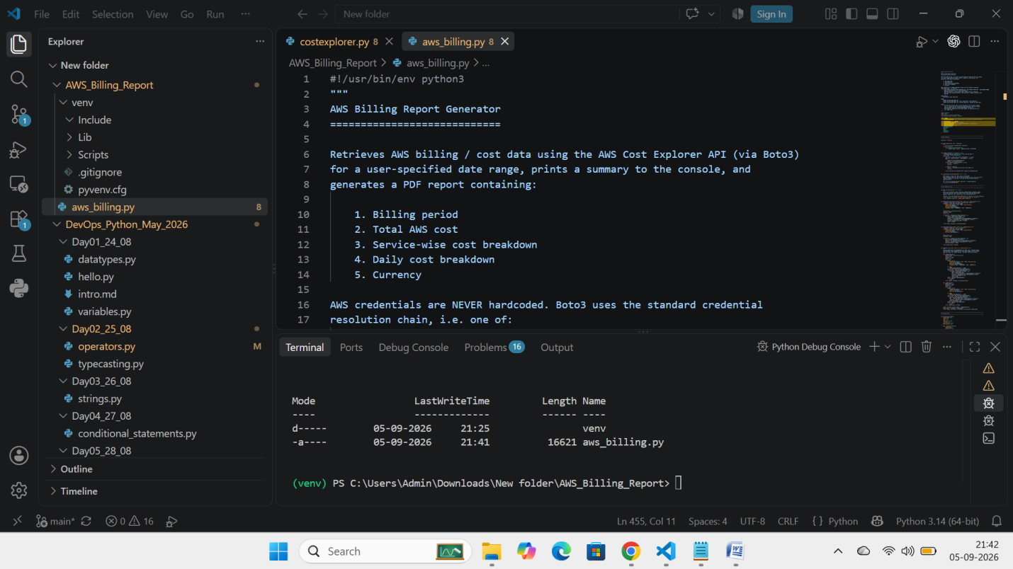

Step 7: Create Python file as aws_billing.py and paste the python code.

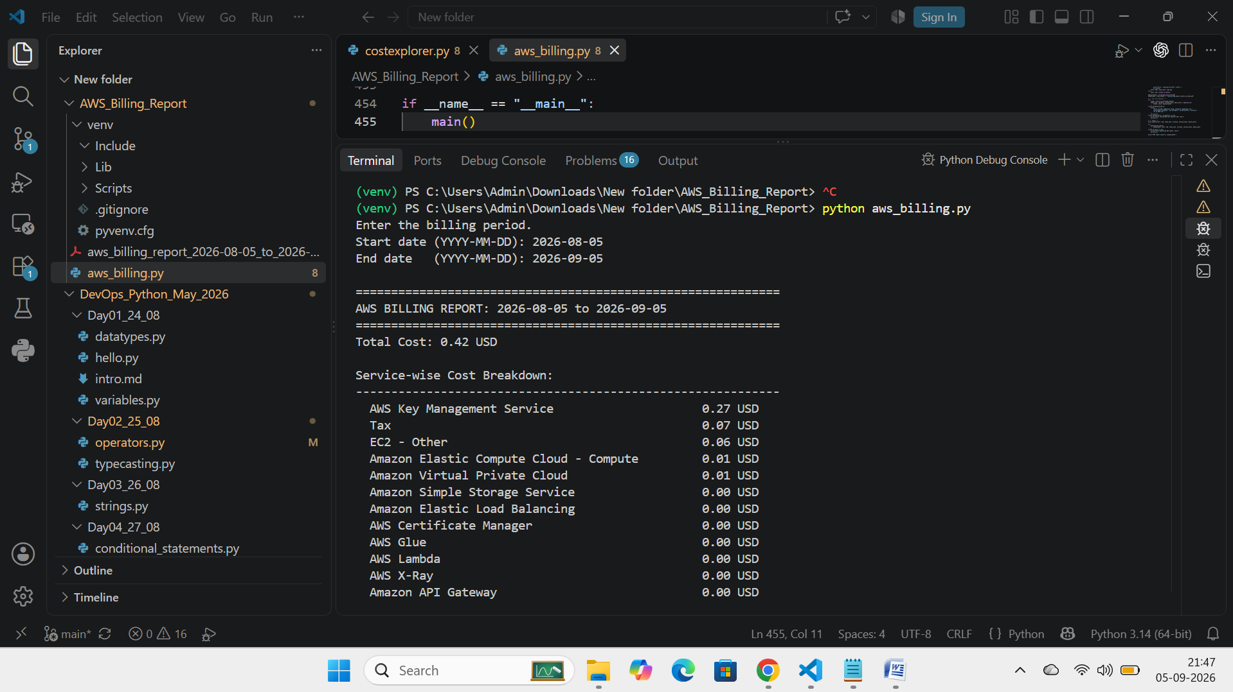

Step 8: Run the Python file

Python aws_billing.py it will ask the start date and End Date
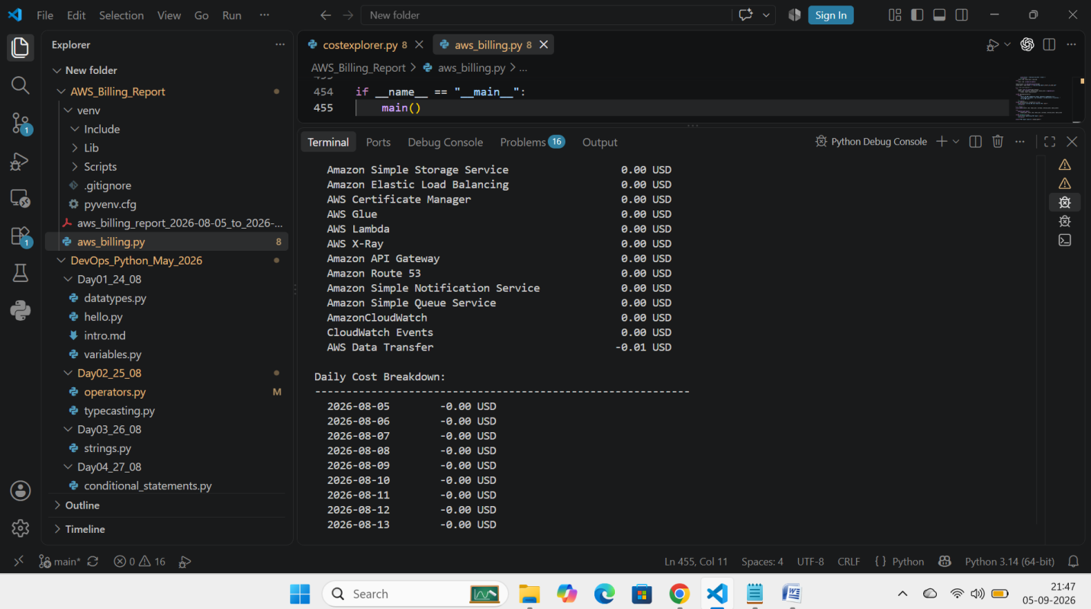
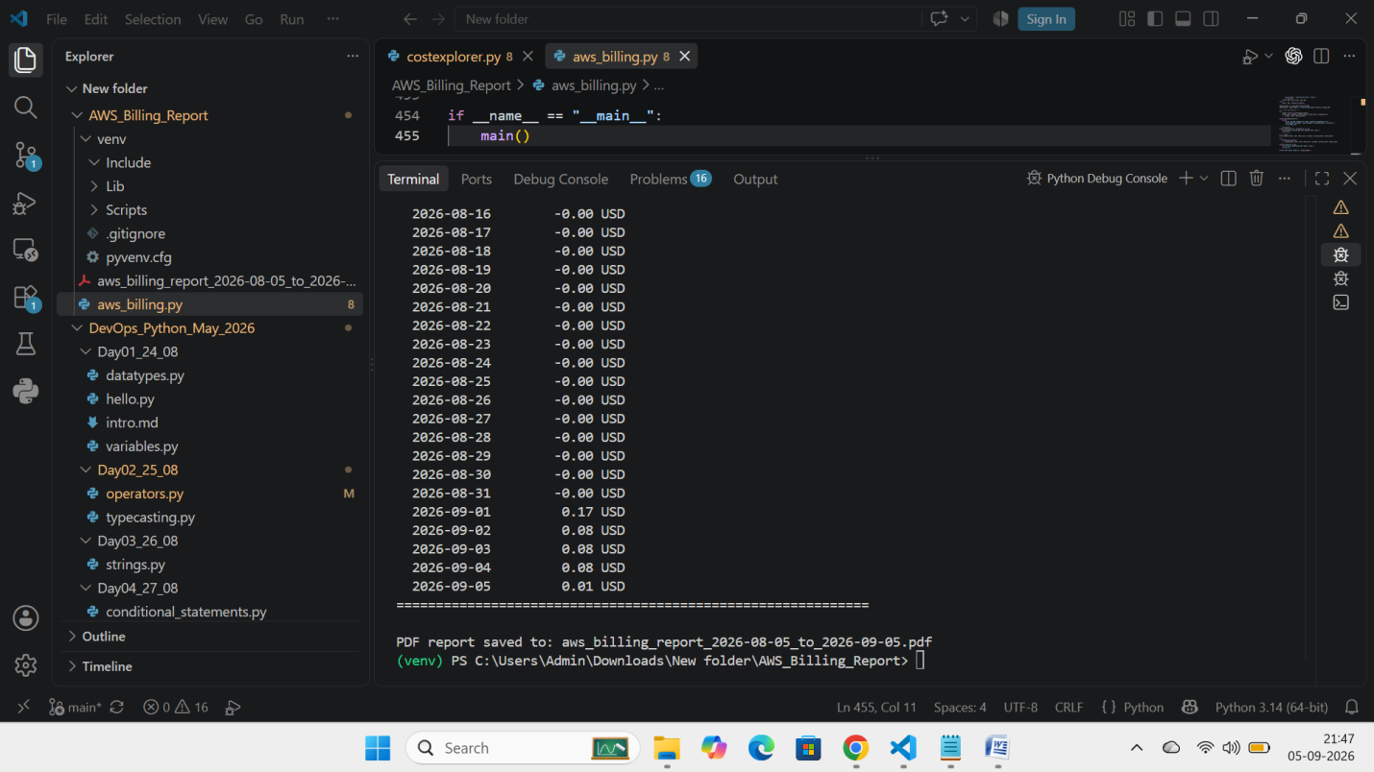

Step 9: Excute the Output
after run the command it will connect Connect to Cost Explorer API in AWS by Boto3 and gives the output and PDF report

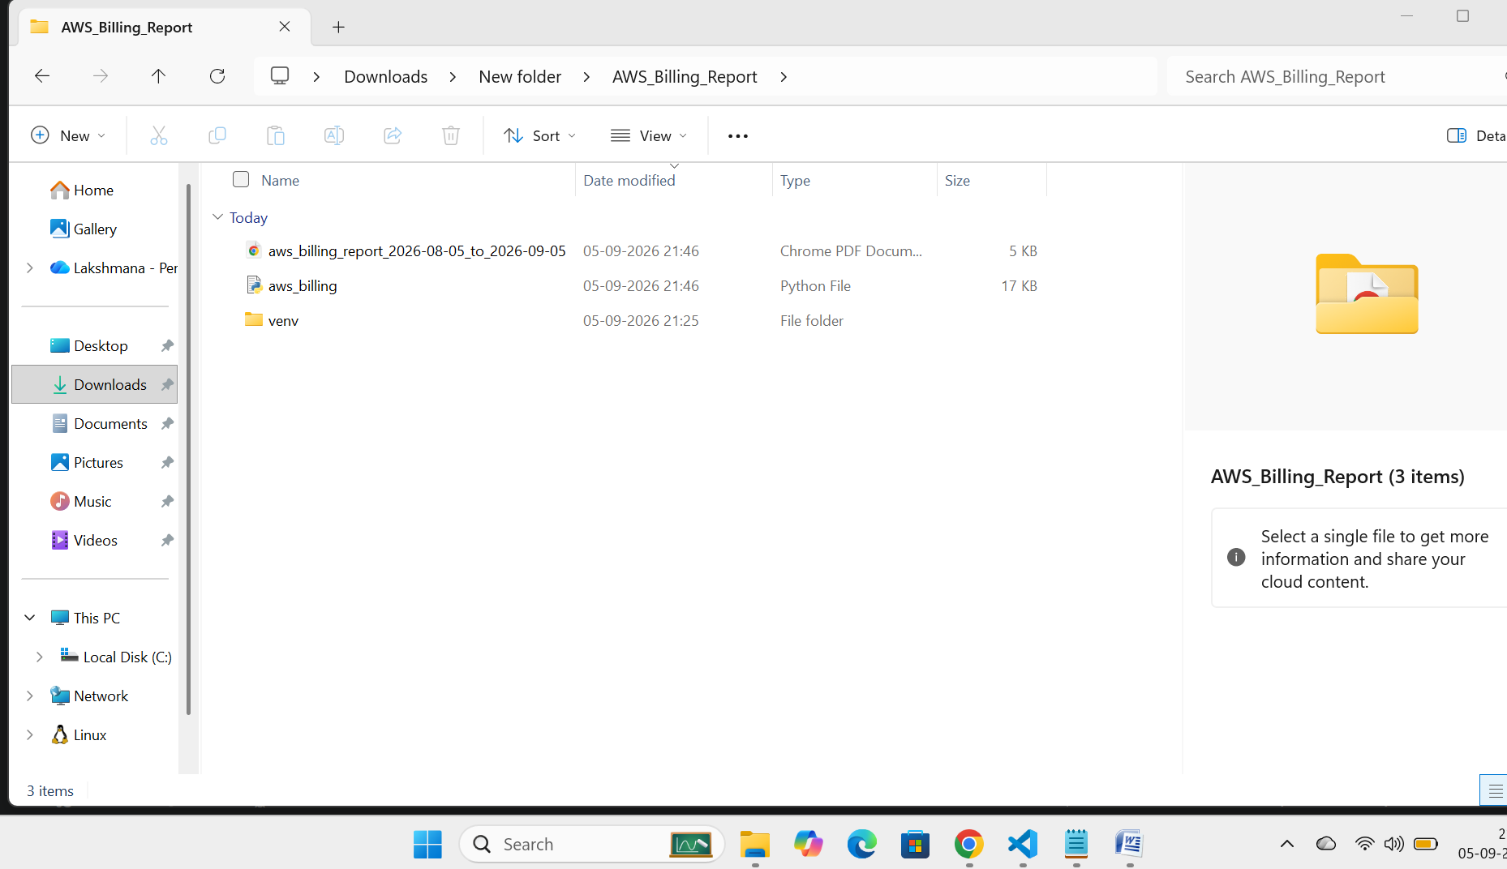
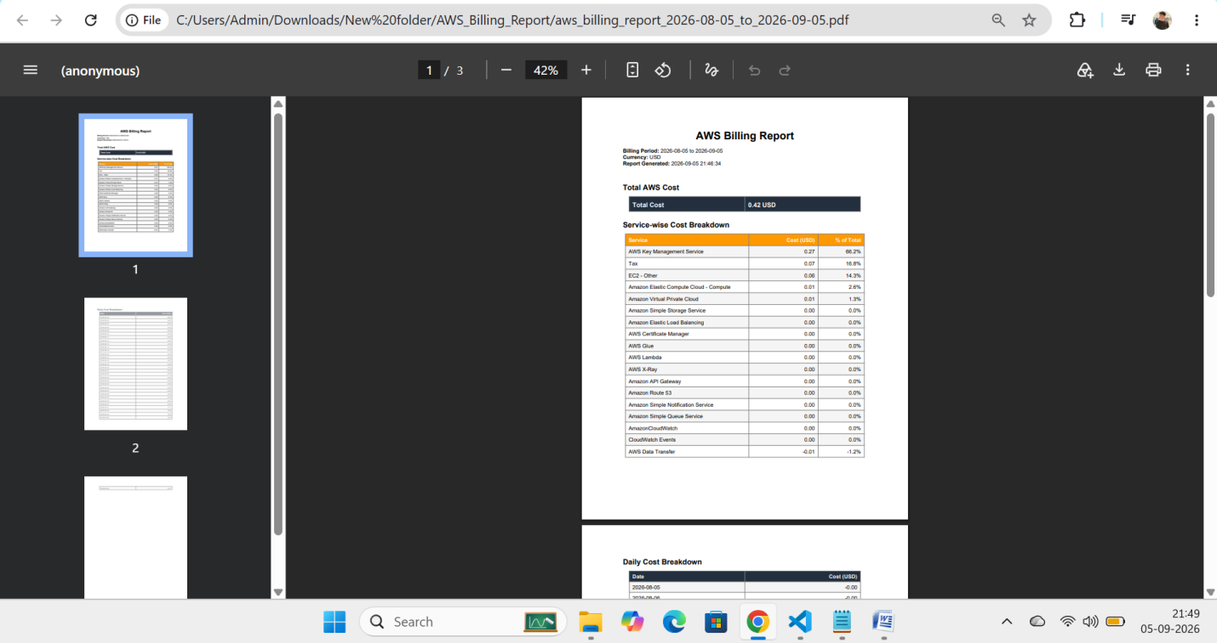
Step 10: Final Output as PDF

• Python project setup
• venv creation and activation
• Boto3 and ReportLab installation
• AWS credential configuration
• Cost Explorer API
• Total cost retrieval
• Service-wise cost retrieval
• Daily cost retrieval
• PDF generation

